Arsdeep Kaur (A01)

200465607

Design and Implementation Assignment

1. Design a database
   1. No assumptions

1.2 Normalization

Unnormalized Form:

Payroll (StartDate, EndDate, EmployeeName, Department, EmployeeNumber, Address, City, Province, PostalCode, EarningsDescription,EarningsCurrentAmount,EarningsYearToDateAmount, TotalEarnings, DeductionsDescription, DeductionsCurrentAmount, DeductionsYearToDateAmount, TotalDeductions, NetPay, EmployerPaidBenefitsDescription, EmployerPaidBenefitsCurrentAmount, EmployerPaidBenefitsYearToDateAmount)

First Normal Form:

Payroll (StartDate, EmployeeNumber, EndDate, EmployeeName, Department, Address, City, Province, PostalCode, TotalEarnings, TotalDeductions, NetPay)

Earnings (StartDate, EmployeeNumber , EarningsDescription, EarningsCurrentAmount, EarningsYearToDateAmount)

Deductions (StartDate, EmployeeNumber ,DeductionsDescription, DeductionsCurrentAmount, DeductionsYearToDateAmount)

EmployerPaidBenefits(StartDate, EmployeeNumber ,EmployerPaidBenefitsDescription, EmployerPaidBenefitsCurrentAmount, EmployerPaidBenefitsYearToDateAmount)

Second Normal Form/ Third Normal Form:

Payroll (StartDate, EmployeeNumber, TotalEarnings, TotalDeductions, NetPay)

Employee (EmployeeNumber, EmployeeName, Deapartment, Address, City, Province, PostalCode)

PayPeriod (StartDate, EndDate)

Earnings (StartDate, EmployeeNumber , EarningsDescription, EarningsCurrentAmount, EarningsYearToDateAmount)

Deductions (StartDate, EmployeeNumber ,DeductionsDescription, DeductionsCurrentAmount, DeductionsYearToDateAmount)

EmployerPaidBenefits(StartDate, EmployeeNumber ,EmployerPaidBenefitsDescription, EmployerPaidBenefitsCurrentAmount, EmployerPaidBenefitsYearToDateAmount)

1.3 High level Data Model

2NF/3NF Data Model

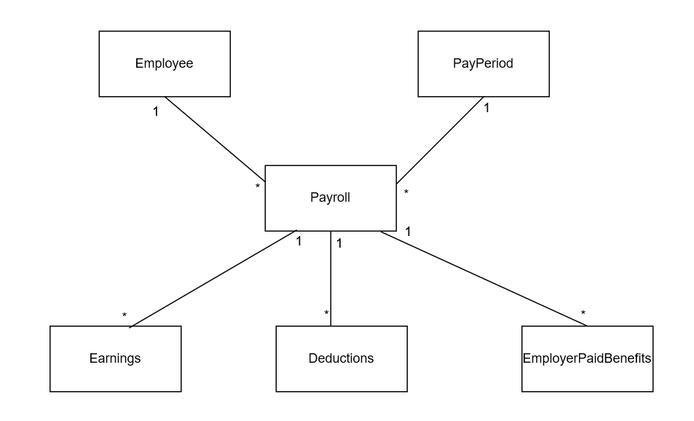

1.4 Data Dictionary

|  |
| --- |
| Employee |
| <<PK>> EmployeeNumber:Number  EmployeeName:Character{size=20}  Department:Character{size=15}  Address:String{size=15}  City:Character{size=15}  Province:Character{size=15}  PostalCode:String{size=7,Create Format=’X9X 9X9’} |

|  |
| --- |
| PayPeriod |
| <<PK>> StartDate:date{Format=’mm\dd\yyyy’}  EndDate:date{Format=’mm\dd\yyyy’} |

|  |
| --- |
| Payroll |
| <<PK>><<FK>> StartDate:date{key=PK,order=1, reference = PayPeriod, format=’mm\dd\yyyy’}  <<PK>><<FK>>EmployeeNumber: Number{key=PK,order=2, reference=Employee}  TotalEarnings: Currency{ TotalEarnings >=0}    TotalDeductions:Currency{ TotalDeductions >=0}  NetPay:Currency{ NetPay >=0} |

|  |
| --- |
| Earnings |
| <<PK>><<FK>>StartDate:date{key=PK, order=1, key=FK, order=1, reference=Payroll, format=’mm\dd\yyyy’}  <<PK>><<FK>>EmployeeNumber:Number{key=PK, order=2, key=FK, order=2, reference=Payroll, format=’mm\dd\yyyy’}  <<PK>> EarningsDescription:String{key=PK, order=3, size=20}  EarningsCurrentAmount:Currency{ EarningsCurrentAmount >=0}  EarningsYearToDateAmount:Currency{ EarningsYearToDateAmount >=0} |

|  |
| --- |
| Deductions |
| <<PK>><<FK>>StartDate:date{key=PK, order=1, key=FK, order=1, reference=Payroll, format=’mm\dd\yyyy’}  <<PK>><<FK>>EmployeeNumber:Number{key=PK, order=2, key=FK, order=2, reference=Payroll, format=’mm\dd\yyyy’}  <<PK>>DeductionsDescription:String{key=PK, order=3, size=20}  DeductionsCurrentAmount:Currency{ DeductionsCurrentAmount >=0}  DeductionsYearToDateAmount:Currency{ DeductionsYearToDateAmount >=0} |

|  |
| --- |
| EmployerPaidBenefits |
| <<PK>><<FK>>StartDate:date{key=PK, order=1, key=FK, order=1, reference=Payroll, format=’mm\dd\yyyy’}  <<PK>><<FK>>EmployeeNumber:Number{key=PK, order=2, key=FK, order=2, reference=Payroll, format=’mm\dd\yyyy’}  <<PK>>EmployerPaidBenefitsDescription{key=PK, order=3, size=20}  EmployerPaidBenefitsCurrentAmount:Currency{ EmployerPaidBenefitsCurrentAmount>=0}  EmployerPaidBenefitsYearToDateAmount:Currency{  EmployerPaidBenefitsYearToDateAmount>=0} |

1. Implement your design

2.1 Transact SQL Statements

Create database PayrollStatement

use PayrollStatement

create table Employee(EmployeeNumber int NOT NULL PRIMARY KEY,

EmployeeName varchar(20) NOT NULL,

Department varchar(15) NOT NULL,

Address varchar(15) NOT NULL,

City varchar(15) NOT NULL,

Province varchar(15) NOT NULL,

PostalCode varchar(7) NOT NULL)

Insert into Employee(EmployeeNumber,EmployeeName,Department,Address,City,Province,PostalCode) VALUES(1,'Arsh','IT','15125','Ed','AB','T5Y0S2')

Create table PayPeriod(StartDate date NOT NULL PRIMARY KEY,

EndDate date NOT NULL)

Insert into PayPeriod(StartDate,EndDate) values('01/01/2019','01/14/2019')

Create table Payroll(StartDate date NOT NULL,

EmployeeNumber int NOT NULL,

TotalEarnings money NOT NULL CHECK(TotalEarnings >=0),

TotalDeductions money NOT NULL CHECK(TotalDeductions > = 0),

NetPay money NOT NULL CHECK(NetPay>=0))

Alter table Payroll add constraint PK Primary Key(StartDate,EmployeeNumber)

Alter table Payroll add constraint FK_1 Foreign Key(StartDate) references PayPeriod(StartDate)

Alter table Payroll add constraint FK_2 Foreign key(EmployeeNumber) references Employee(EmployeeNumber)

Insert into Payroll(StartDate,EmployeeNumber,TotalEarnings,TotalDeductions,NetPay) values('01/01/2019',1,1200,100,1100)

Create table Earnings(StartDate date NOT NULL,

EmployeeNumber int NOT NULL,

EarningsDescription varchar(20) NOT NULL,

EarningsCurrentAmount money NOT NULL CHECK(EarningsCurrentAmount>=0),

EarningsYearToDateAmount money NOT NULL CHECK(EarningsYearToDateAmount>=0))

Alter table Earnings add constraint PK_E Primary Key(StartDate,EmployeeNumber,EarningsDescription)

Alter table Earnings add constraint FK_E Foreign Key(StartDate,EmployeeNumber) references Payroll(StartDate,EmployeeNumber)

Insert into Earnings(StartDate,EmployeeNumber,EarningsDescription,EarningsCurrentAmount,EarningsYearToDateAmount) values('01/01/2019',1,'abcd',1000,12000)

Create table Deductions(StartDate date NOT NULL,

EmployeeNumber int NOT NULL,

DeductionsDescription varchar(20) NOT NULL,

DeductionsCurrentAmount money NOT NULL CHECK(DeductionsCurrentAmount>=0),

DeductionsYearToDateAmount money NOT NULL CHECK(DeductionsYearToDateAmount>=0))

Alter table Deductions add constraint PK_D Primary Key(StartDate,EmployeeNumber,DeductionsDescription)

Alter table Deductions add constraint FK_D Foreign Key(StartDate,EmployeeNumber) references Payroll(StartDate,EmployeeNumber)

Insert into Deductions(StartDate, EmployeeNumber, DeductionsDescription, DeductionsCurrentAmount,DeductionsYearToDateAmount) values('01/01/2019',1,'abcd',100,1200)

Create table EmployerPaidBenefits(StartDate date NOT NULL,

EmployeeNumber int NOT NULL,

EmployerPaidBenefitsDescription varchar(20) NOT NULL,

EmployerPaidBenefitsCurrentAmount money NOT NULL check(EmployerPaidBenefitsCurrentAmount>=0),

EmployerPaidBenefitsYearToDateAmount money NOT NULL CHECK(EmployerPaidBenefitsYearToDateAmount>=0))

Alter table EmployerPaidBenefits add constraint PK_EPB Primary Key(StartDate,EmployeeNumber,EmployerPaidBenefitsDescription)

Alter table EmployerPaidBenefits add constraint FK_EPB Foreign Key(StartDate,EmployeeNumber) references Payroll(StartDate,EmployeeNumber)

Insert into EmployerPaidBenefits(StartDate,EmployeeNumber,EmployerPaidBenefitsDescription,EmployerPaidBenefitsCurrentAmount,EmployerPaidBenefitsYearToDateAmount)

VALUES('01/01/2019',1,'ABCD',2000,24000)